®  34-36 Peyo Yavorov blvd,  Sofia 1164, Bulgaria | tel +359 2 423 4455  proektsoft.bg@gmail.com  https://calcpad.eu

A CALCPAD PROGRAM

FOR MATERIAL AND GEOMETRIC NONLINEAR ANALYSIS OF PRESTRESSED ASYMMETRIC BIOT TRUSS

─◊─◊──◊───◊────⧫────◊───◊──◊─◊─

(using large displacement theory)

by

Eng. Nedelcho Ganchovsky

12.2024
Input data
, ,
Elements - [J1; J2]
, , ,
Element endpoint coordinates
, , ,
Element lengths -
Element directions - ,
Transformation matrix
,
Supports - [joint; cx; cy]
,
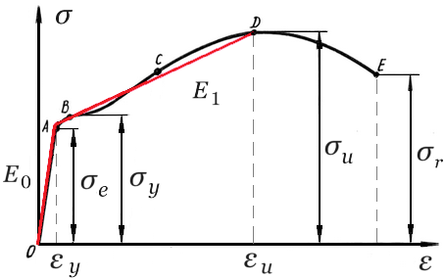
Material - steel
We assume bi-linear material model
Initial modulus of elasticity -
Yield stress -
Ultimate tensile strength -
Yield strain -
Ultimate strain -
Modulus of elasticity after yield -
Idealized stress-strain curve -
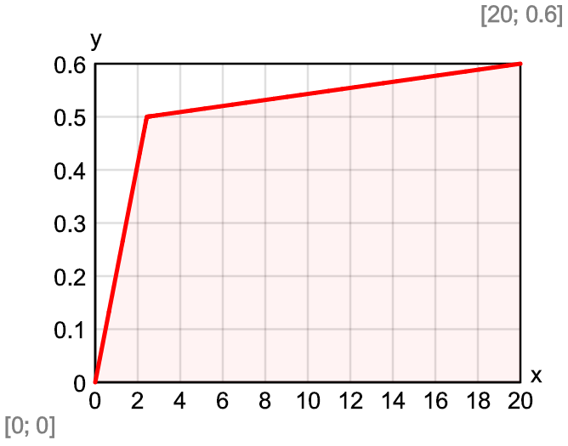
Cross section – circular with diameter
Area -
Stiffness
Initial - ,
After yield -
Load - [Joint, Fx, Fy]
,
Prestressing force -
Initial stress -
Initial strain -
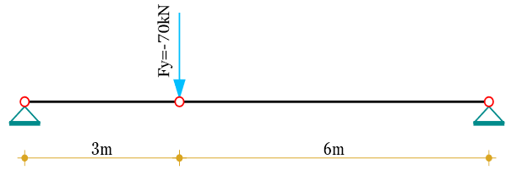
Finite element formulation
We will formulate a 2D truss element with 3rd order geometric nonlinearity. The equilibrium equations will be derived in local CS, for the deformed state of the structure, assuming large displacements, as follows:
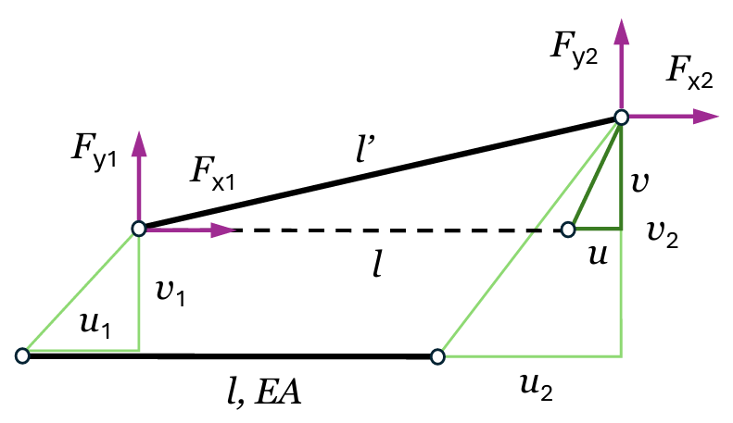
Relative displacements - , ,
Length and elongation of the element in deformed state
, ,
Directions of the displaced axis of the element in the deformed state
,
Axial force in element -
Horizontal reactive force at the right end -
Vertical reactive force at the right end -
Partial derivatives of element end reactive forces
,
,
We are not going to linearize the above equations by Taylor series as per [1]. We will use them further directly in their implicit form.
Solution by Newton-Raphson’s method
We will express the parameters of the system as a function of the vector of t he unknown displacements:

Initial deflection at the intermediate joint -
Extracting displacements for joint j -
Relative displacements for element e -
Element reactive forces partial vector -
Partial element Jacobi matrix

Target precision -
Iteratively calculate the following equations of the Newton-Raphson’s method:
, , ,
Convergence reached at iteration - . Relative error -
Results
Joint displacements -
Joint J2 - Z₂ =
Reactions in supports
, ,
Joint J1 - R₁ =
Joint J3 - R₂ =
Element yield capacity -
Element ultimate capacity -
Element axial forces -
Element Е1 - N₁ =
Element Е2 - N₂ =

Comparison to OpenSeesPy
The solution is performed by the following Python script:
import openseespy.opensees as ops
# Units of measurement
m = 1; N = 1; kN = 1000*N; Pa = N/m**2; MPa = Pa*1e6; GPa = Pa*1e9; cm = m/100
# Model properties
a = 3*m; b = 6*m # Joint spacing
E0 = 206*GPa # Initial modulus of elasticity
fy = 500*MPa # Yield stress
fu = 600*MPa # Ultimate tensile strength
εy = fy/E0 # Yield strain
εu = 0.02 # Ultimate strain
E1 = (fu - fy)/(εu - εy) # Residual modulus of elasticity
d = 2*cm # Cross section diameter
A = 3.14159265359*d**2/4 # Cross section area
F = 70*kN # Vertical load at the intermediate joint
P = 20*kN # Prestressing force
σp = P/A # Initial stress
# Model creation
ops.model('basic','-ndm',2,'-ndf',2)
ops.node(1,0,0); ops.fix(1,1,1)
ops.node(2,a,-1e-6*cm) # Small
ops.node(3,a+b,0); ops.fix(3,1,1)
ops.uniaxialMaterial('ElasticBilin',1,E0,E1,εy)
ops.uniaxialMaterial('InitStressMaterial',2,1,σp)
ops.element('corotTruss',1,1,2,A,2)
ops.element('corotTruss',2,2,3,A,2)
ops.timeSeries('Constant',1)
ops.pattern('Plain',1,1)
ops.load(2,0,-F)
# Running the analysis
ops.analysis('Static','-noWarnings')
ops.analyze(1)
ops.reactions()
# Printing the results
print(f"Displacements: {["%.2fmm" % (f*1000) for f in ops.nodeDisp(2)]}")
print(f"Support reactions: {["%.2fkN" % (f/1000) \
for f in ops.nodeReaction(1)]}, {["%.2fkN" % (f/1000) \
for f in ops.nodeReaction(3)]}")
print(f"Element axial forces: {["%.2fkN" % (f/1000) \
for f in ops.basicForce(1)]}, {["%.2fkN" % (f/1000)
for f in ops.basicForce(2)]}")
Credits: The above code is based on a script, developed by Prof. Michael H. Scott, Oregon State University.
Results:
Displacements: ['-44.71mm', '-772.72mm']
Support reactions: ['-179.81kN', '47.01kN'], ['179.81kN', '22.99kN']
Element axial forces: ['185.85kN'], ['181.27kN']
Conclusion: Both solutions are identical up to five significant digits.
Comparison to linear-elastic material model and system behavior charts
Using the same algorithm in Calcpad, we also performed a solution with linear-elastic material model, by entering sufficiently high values for the yield and tensile strengths. The results are obtained as follows:
Results for linear elastic material model
Joint displacements -
Joint J2 - Z₂ =
Reactions in supports
, ,
Joint J1 - R₁ =
Joint J3 - R₂ =
Element axial forces -
Element Е1 - N₁ =
Element Е2 - N₂ =

Comparison to OpenSeesPy:
Displacements: ['-14.56mm', '-418.88mm']
Support reactions: ['-333.41kN', '46.78kN'], ['-0.00kN', '-0.00kN']
Element axial forces: ['336.68kN'], ['334.22kN']
By applying material nonlinearity, we can activate “hidden” resistance resources that exists in the structure. Yielding allows the structure to deflect further and work more efficiently, due to the increased vertical projection of the internal axial forces in bars.
By gradually increasing the load at a certain step and recording the corresponding displacements and forces, we can track the behavior of the system and display it graphically. This was done for both models – linear and nonlinear material models, and the results are displayed in the following diagrams:

Until the steel yields the two graphs coincide completely. From then on, they diverge. The displacements for the bi-linear material model grow faster, while the forces grow more slowly. The first graph clearly shows zero initial stiffness (zero tangent slope). That is why the system cannot be solved by linear analysis or assuming small displacements (1-st and 2-nd order theories).

References
- Levy, R., Spillers, W.R. Analysis of Geometrically nonlinear structures: Second Edition (2003) Analysis of Geometrically nonlinear structures: Second Edition, p. 272. DOI: 10.1007/978-94-017-0243-0
- McKenna, F., Fenves, G. L, and Scott, M. H. (2000) Open System for Earthquake Engineering Simulation. University of California, Berkeley
http://opensees.berkeley.edu
- Mazzoni, S., McKenna, F., Scott, M. H., and Fenves, G. L. (2006) OpenSees Command Language Manual. University of California, Berkeley
http://opensees.berkeley.edu/manuals/usermanual
- Minjie Zhu, Frank McKenna, Michael H. Scott, OpenSeesPy: Python library for the OpenSees finite element framework, SoftwareX, Volume 7, 2018, Pages 6-11, ISSN 2352-7110
https://doi.org/10.1016/j.softx.2017.10.009

